**VISVESVARAYA TECHNOLOGICAL UNIVERSITY**

**JNANASANGAMA, BELGAVI-590018**

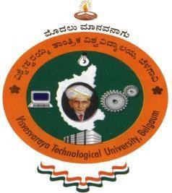

# AICTE ACTIVITY POINTS REPORT

Submitted in partial fulfilment of the requirements for the award of degree

**Submitted by**

Yuvanyash Moorthy Rameshbabu

1BI19IS063

Under the Guidance of

**Dr. Roopa K M** Professor and Dean- Skill Development Dept of Maths, BIT

Organized by

SKILL DEVELOPMENT CENTRE & CICC, BIT IN

COLLABORATION WITH

KARNATAKA SCIENCE AND TECHNOLOGY ACADEMY(KSTA)



**2022-2023**

**DEPARTMENT OF INFORMATION SCIENCE AND ENGINEERING BANGALORE INSTITUTE OF TECHNOLOGY**

**K. R. Road, V. V. Pura, Bengaluru-560004**

 **VISVESVARAYA TECHNOLOGICAL UNIVERSITY**

### JNANASANGAMA, BELAGAVI-590018, Karnataka

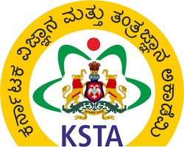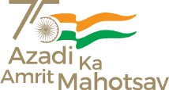**BANGALORE INSTITUTE OF TECHNOLOGY**

### K.R. Road, V.V. Puram, Bengaluru-560004

**DEPARTMENT OF INFORMATION SCIENCE & ENGINEERING**

# CERTIFICATE

This is to certify that **Mr. Yuvanyash Moorthy Rameshbabu** bearing USN **1BI19IS063** is a bonafide student and has been actively involved in AICTE Activities organized by Skill Development Centre & CICC, Bit in Collaboration With Karnataka Science And Technology Academy (KSTA) and successfully completed the all the activities for the partial fulfillment for the award of the degree of Bachelor of Engineering in Information Science and Engineering under Visvesvaraya Technological University, Belagavi during the year 2022-2023. The report has been approved as it satisfies the requirements in respect of AICTE Activity.

## Activity Points Earned: 10 points

**Mrs. Anupama K C Dr. Roopa K M**

Assistant Professor

Activity Point Coordinator(AICTE)

Dept of ISE,BIT

Professor and Dean- Skill Development

CICC-Coordinator BIT Bangalore

# ABSTRACT

The objectives of AICTE student activity are to expose students to real-time life challenges and to provide the opportunity to gather data, analyze data, propose solutions, and implement solutions. Also, it paves the way for personal development and creative engineers who are proud volunteers with a sense of achievement and ready to take up projects having a social impact and create digital awareness. Besides, it helps the students to strengthen their soft skills, leadership qualities, and team spirit. Moreover, these activities inculcate an entrepreneurial mindset and societal commitment. Apart from technical knowledge and skills, to be successful as professionals, students should have excellent soft skills, leadership qualities, and team spirit. They should have entrepreneurial capabilities and societal commitment.

# ACKNOWLEDGEMENT

The satisfaction and euphoria that accompanies the successful completion of any task would be incomplete without complementing those who made it possible and whose guidance and encouragement made my efforts successful. So, my sincere thanks to all those who have supported me in completing this Activity successfully.

My sincere thanks to **Dr. M. U. Aswath**, Principal, BIT, **Dr. Jaypraskash,** Vice-Principal, BIT, **Dr. Roopa K. M**, Dean, Skill Development Centre, BIT and **Dr. Asha T**, Associate Professor, Department of ISE, BIT, **Dr. Roopa H**, Associate Professor, Department of ISE, BIT, and **Mrs. Anupama K C**, Assistant Professor, Department of ISE, BIT for their encouragement, support and, guidance to the student community in all fields of education. I am grateful to our institution for providing us a with congenial atmosphere to carry out the Activity successfully.

My sincere thanks to **Dr. A. M. Ramesh**, Chief Executive Officer, KSTA, Government of Karnataka for their encouragement, support, and guidance. My sincere thanks to **Mr. Sundaresh,** Principal, VGKK, BR Hills.

I extend my sincere thanks to all the department faculty members and non-teaching staff for supporting me directly or indirectly in the completion of this Activity.

**YUVANYASH MOORTHY RAMESHBABU**

**1BI19IS063**

# TABLE OF CONTENTS

|  |  |  |  |  |  |  |  |  |  |  |  |  |  |  |  |
| --- | --- | --- | --- | --- | --- | --- | --- | --- | --- | --- | --- | --- | --- | --- | --- |
| |  |  | | --- | --- | | **CHAPTER 1 - INTRODUCTION** | 1 | | **CHAPTER 2 - ABOUT THE DEPARTMENT** |  | | 2.1  Skill Development Centre | 3 | | 2.2  College Internal Complaint Cell (CICC) | 4 | | 2.3  Karnataka Science and Technology Academy | 4 | | **CHAPTER 3 - DESCRIPTION OF AICTE ACTIVITIES CONDUCTED** |  | | 3.3 ACTIVITY 1- Contributing to Python Programming for 1st sem |  | |  |
|  |  |
|  |  |
|  |  |
|  |  |
|  |  |

|  |  |
| --- | --- |
|  |  |

**LIST OF FIGURES**

|  |  |  |
| --- | --- | --- |
| Fig 1. | Output 1 | 7 |
| Fig 2. | Output 2 | 8 |
| Fig 3. | Output 3 | 9 |
| Fig 4. | Output 4 | 10 |

# 1. INTRODUCTION

The objectives of AICTE student activity is to expose students to real-time life challenges, to provide the opportunity to gather data, analyse data, propose solutions and implement solutions. Also, it paves the way for personal development and creative engineers who are proud volunteers with a sense of achievement and ready to take up projects having a social impact and creating digital awareness. Besides, it helps the students to strengthen their soft skills, leadership qualities and team spirit. Moreover, these activities inculcate entrepreneurial mindset and societal commitment.

Apart from technical knowledge and skills, to be successful as professionals, students should have excellent soft skills, leadership qualities and team spirit. They should have entrepreneurial capabilities and societal commitment. In order to match these multifarious requirements, AICTE has created a unique mechanism of awarding minimum of 50 Activity Points over and above the academic grades. Every regular student, who is admitted to the 4 years Degree programme, is required to earn 100 Activity Points in addition to the required academic grades, for getting 4 Years degree programme. Students entering 4 years Degree programme through lateral entry are required to earn 50 Activity Points, in addition to the academic grades, for getting 4 years’ degree program. Similarly, Diploma students are required to earn 25 Activity Points during 3 years of their diploma program. AICTE recommends 300-400 hours Activity Programme for each degree student for Community service and allied activities. Similarly, 200-250 hours should be devoted by Diploma students for Community service and allied activities as an additional requirement or non-credit program. Here, 40-45 hours are equivalent to 1 week. These activities will be coordinated by NSthe S/NCC/CICC/Sports/SAGY Coordinator or TPO of the Institute. The student will be provided a certificate from the concerned coordinator and Institutional Head. Every student is required to prepare a file containing documentary proofs of activities, done by him/ her. The student should earn at least 50 activity points before he/ she appears for his/ her Final Examinations. The points students have earned will be reflected on the student’s transcript. However, there will be neither grades/ marks for these points nor will there be any effect on SPI/CPI/CGPA etc. As proposed under the AICTE Rural Internship Programme, if a student completes any long-term goal during his degree programme, it will be counted as Internship Activity and credit requirement for the internship is fulfilled. However, if only short-term interventions under the programme are attempted it will be counted towards AICTE Activity Point Programme requisite.

Following suggestive activities as long term Goals may be carried out by students in teams:

1. Prepare and implement plan to create local job opportunities.
2. Prepare and implement plan to improve education quality in village.
3. Prepare an actionable DPR for Doubling the village Income.
4. Developing Sustainable Water Management system.
5. Prepare and improve a plan to improve health parameters of villagers.
6. Developing and implementing of low cost Sanitation facilities.
7. Prepare and implement plan to promote Local Tourism through Innovative Approaches.
8. Implement/Develop Technology solutions which will improve quality of life.
9. Prepare and implement solution for energy conservation.
10. Prepare and implement plan to Skill village youth and provide employment.
11. Develop localized techniques for Reduction in construction Cost.
12. Prepare and implement plan of sustainable growth of village.
13. Setting of Information imparting club for women leading to contribution in social and economic issues.
14. Developing and managing Efficient garbage disposable system.
15. Contribution to any national level initiative of Government of India. For eg. Digital India/ Skill India/ Swachh Bharat Internship etc

The student may choose any activities as per their liking in order to earn the AICTE Activity points. These activities can be spread over the years, as per convenience of the student.

But due to the covid-19 pandemic the points to be earned by every regular student is reduced to 50 points and for lateral entry student it is reduced to 25 points.

Following are the various activities conducted by the institution to enable AICTE activity points.

1. Creating public awareness to upskill rural people under rural outreach programme (Rural India).
2. Helping local schools to achieve good result and enhance their enrolment in Higher/ technical/ Vocational Education.
3. Contribution to National level Initiative of Government of India (Digital India/Skill India).

# ABOUT THE ORGANIZING DEPARTMENT

The AICTE activities were organized by Skill Development Centre, College Internal Complaint Cell (CICC) in collaboration with Karnataka Science and Technology Academy (KSTA).

## Skill Development Centre:

The higher education of the 21st century faces several challenges in providing skill-centric learning, meeting the needs of the industry and society in the global arena. In order to overcome such challenges, Bangalore Institute of Technology (BIT) aims to upgrade skills to universal standards through significant industry participation and develop necessary frameworks of standards for quality assurance. The institute believes that skills are as essential as one's academic status. Thus, education and skills should go hand in hand to empower students, safeguard their future, and the overall development of an individual.

Objectives of Skill Development Centre:

* To conduct various skill development programs to students and improve their employability.
* To promote entrepreneurship to address societal issues.
* To endorse the knowledge exchange programs.
* To increase employability, leadership qualities of faculty and students.
* To improve the technical and writing skills and researchable activities of faculty and students.
* To facilitate the industrial institutional interactions.
* Improvement in the learning potentialities and enhancing self-confidence of faculty and students.
* Preparing women for economic independence.

Members of the Committee:

|  |  |  |
| --- | --- | --- |
| SL No | Members | Designation |
| 1. | Dr Roopa K M | Dean |
| 2. | Dr Gunavathi | Associate Dean |

## 2.2 College Internal Complaint Cell (CICC):

The vision of the Cell is to provide a healthy and safety environment to uphold the dignity of the Students and Employees.

Objectives of CICC:

* To build self-confidence and nobility among employees of the institution.
* To create awareness regarding women rights.
* To avoid and forbid sexual harassment at workplace.
* To promote counselling, legal aid in case of harassment against employees.

Members of the Committee:

|  |  |  |
| --- | --- | --- |
| SL No | Members | Designation |
| 1. | Dr Roopa K M | Coordinator |

## 2.3 Karnataka Science and Technology Academy:

The Karnataka Science and Technology Academy (KSTA) is an organization established in 2005 to promote [science](https://en.wikipedia.org/wiki/Science) and [technology](https://en.wikipedia.org/wiki/Technology)-related activities in the Indian [State](https://en.wikipedia.org/wiki/States_and_union_territories_of_India) of [Karnataka.](https://en.wikipedia.org/wiki/Karnataka) It functions under the Department of Science and Technology of the [government of Karnataka](https://en.wikipedia.org/wiki/Government_of_Karnataka). The KSTA organizes programmes and conferences across Karnataka with an aim to "bring scientific awareness" and "popularize... science among general public." The body is headed by a chairman and includes 20 other members, that includes 14 nominated members and 5 [ex](https://en.wikipedia.org/wiki/Ex_officio_members) [officio members](https://en.wikipedia.org/wiki/Ex_officio_members): secretaries, principal secretaries, and directors of other departments of the government of Karnataka.

Vision

* To nurture and enable Knowledge, Science, & Technology for All.

Mission

* To play a pivotal role in science promotion, Technology dissemination and fostering Innovations for Societal Welfare.

Objectives of KSTA:

* To inculcate scientific temper across civil society through science communication, particularly in Kannada.
* To facilitate technology dissemination through Academia-Farm-Industry interface, with a focus on rural areas.
* To foster Innovations & Entrepreneurship for societal benefits to recognise talents and contributions through Awards.
* To organise Conferences & Outreach programmes to serve as Resource Centre for Capacity building in frontier areas of Science & Technology.
* To act as a Science, Technology & Innovation Policy Advisory Body for the State.

Members of the Committee:

|  |  |  |
| --- | --- | --- |
| SL No | Members | Designation |
| 1. | Prof. S. Ayyappan | Chairman |
| 2. | Shri Basavaraju A. B., IAS | Member Secretary |
| 3. | Dr A. M. Ramesh | Chief Executive Officer |

**3.DESCRIPTION AICTE ACTIVITIES CONDUCTED**

## 3.1 ACTIVITY 1 - Contributing by writing python programs to first semester student’s lab manual

Dr. K M Roopa, the Professor and Dean of Skill Development at the Department of Mathematics, BIT gave us an opportunity to earn activity points by writing python code for the junior batch (1st semester) students for their lab manual on the topic of **“2D Plot for polar and cartesian curves” and “Solution of system of linear equations using Gauss Seidel Iteration”**

The activity was conducted for three days and involved understanding the theory behind the polar and cartesian curves. The Python code allowed the students to implement the 2D Plot for polar and cartesian curves.

**CODE 1:**

import math

import numpy as np

import matplotlib.pyplot as plt

#function that returns cartesian

def y(x):

return x**2+x

#function that returns polar

def r(t):

return np.sin(t) + np.cos(t)

#function for cartesian plot

def plot_cartesian():

# list of values of x

xs = np.linspace(0, 4, 1000)

#to append the values in the graph for each value of xs

ys = [y(i) for i in xs]

#plot for the values of x and y

plt.plot(xs, ys)

#display the graph

plt.show()

def plot_polar():

#list of values of theta

ts = np.linspace(0, np.pi, 1000)

# to append the values in the graph for each value of ts

rs = [r(i) for i in ts]

# plot for the values of theta

plt.polar(ts, rs)

#display the graph

plt.show()

#call the functions defined

plot_cartesian()

plot_polar()

**OUTPUT 1:**

**2D plot for cartesian curve**

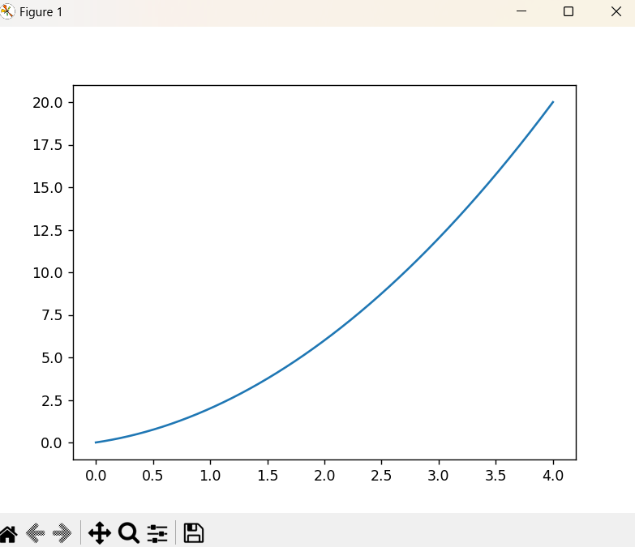

**OUTPUT 2:**

**2D plot for polar curve**

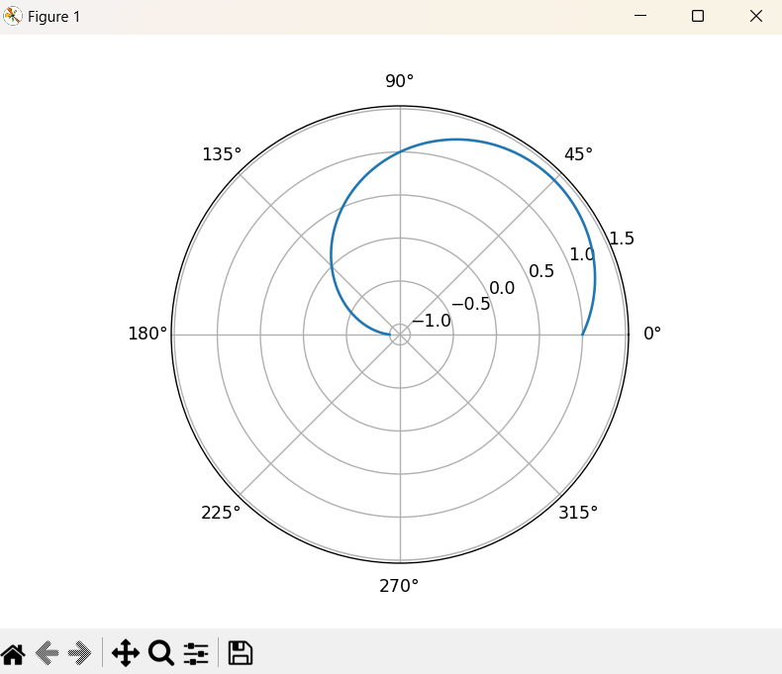

**CODE 2:**

# Gauss Seidel Iteration

# Defining equations to be solved

# in diagonally dominant form

# reeduce to the form of x y and z expressions

# create expressions for each using lambda to substitute the values

f1 = lambda x, y, z: (7 - y - z)

f2 = lambda x, y, z: (13 - x - z) / 3

f3 = lambda x, y, z: (13 - x - 2 * y) / 2

# Initial setup

x0 = 0

y0 = 0

z0 = 0

count = 1

# number of iterations

n = float(input('Enter total number of iterations: '))

# Implementation of Gauss Seidel Iteration

print('\nCount\tx\ty\tz\n')

condition = True

while condition:

x1 = f1(x0, y0, z0)

y1 = f2(x1, y0, z0)

z1 = f3(x1, y1, z0)

print('%d\t%0.4f\t%0.4f\t%0.4f\n' % (count, x1, y1, z1))

count = count + 1

x0 = x1

y0 = y1

z0 = z1

condition = count <= n

print('\nSolution: x=%0.3f, y=%0.3f and z = %0.3f\n' % (x1, y1, z1))

**OUTPUT 3:**

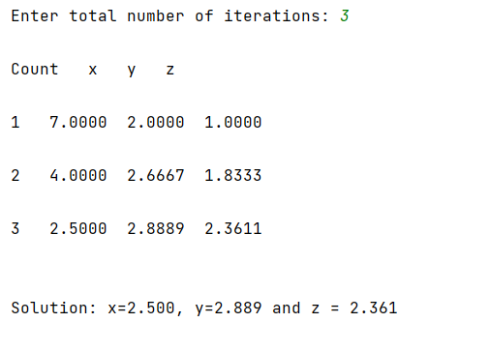

**OUTPUT 4:**

